Project Report

Optimizing User, Group, and Role Management with Access Control and Workflows

Team Members:
- HARISH S(Team Leader)
- ARAVIND MALAVAN V
- VIGNESH M
- SHIVANAMBI R

Project description:
- This project aims to optimize user, group, and role management by implementing automated workflows and access control policies. It ensures secure and efficient access provisioning, reduces manual tasks, and maintains compliance. The system enhances operational efficiency by providing role-based permissions and approval workflows.
Steps for the instance:
  - Sign up for a developer account on the ServiceNow Developer site
“https://developer.servicenow.com”.
  - Once logged in, navigate to the "Personal Developer Instance" section.
  - Click on "Request Instance" to create a new ServiceNow instance.
  - Fill out the required information and submit the request.
  - You'll receive an email with the instance details once it's ready.
  - Log in to your ServiceNow instance using the provided credentials.
  - Now you will navigate to the ServiceNow.
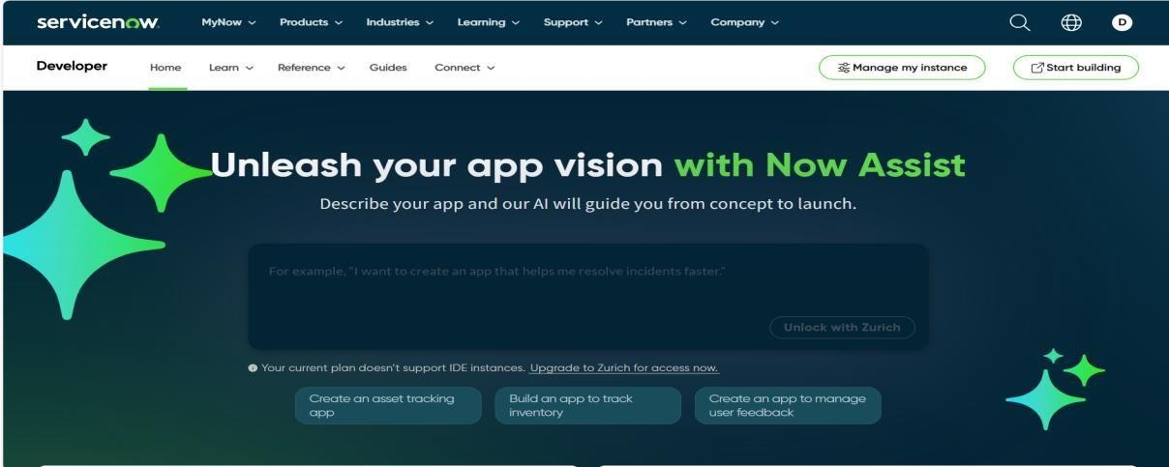
Next:
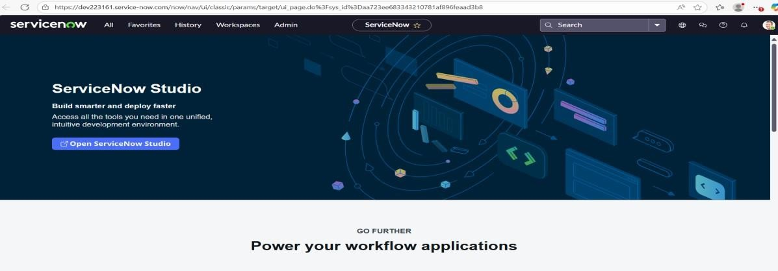

Create Users :
- Open ServiceNow and log in to your instance.
- Click on All in the navigation pane and search for Users.
- Select Users under the System Security module.
- Click on the New button to create a new user record
- Fill in the required user details such as Name, User ID, Email, and Password.
- Click on the Submit button to save and create the new user.
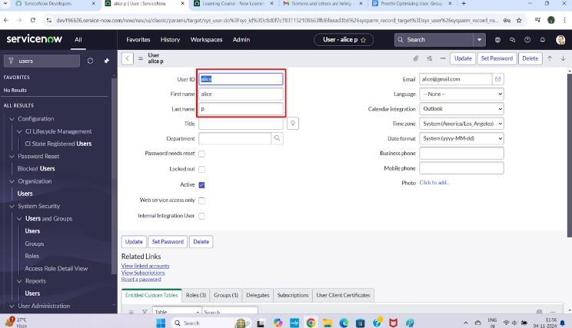

Create Groups :
- Open ServiceNow and log in to your instance.
- Click on All in the navigation pane and search for Groups.
- Select Groups under the System Security module.
- Click on the New button to create a new group record.
- Fill in the required group details such as Name, Description, and Manager→project team.
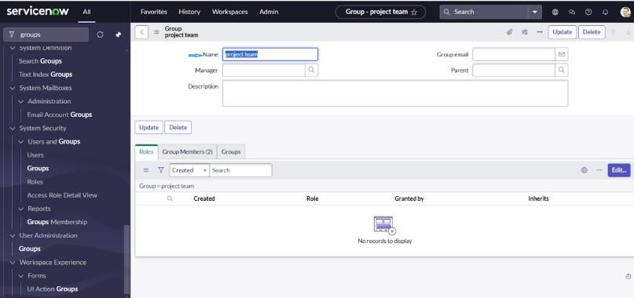
- Click on the Submit button to save and create the new group.

Create Roles :
- Click on All in the navigation pane and search for Roles.
- Select Roles under the System Security module.
- Click on the New button to create a new role record.
- Fill in the required role details such as Name and Description→project member.
- Click on the Submit button to save and create the new role.
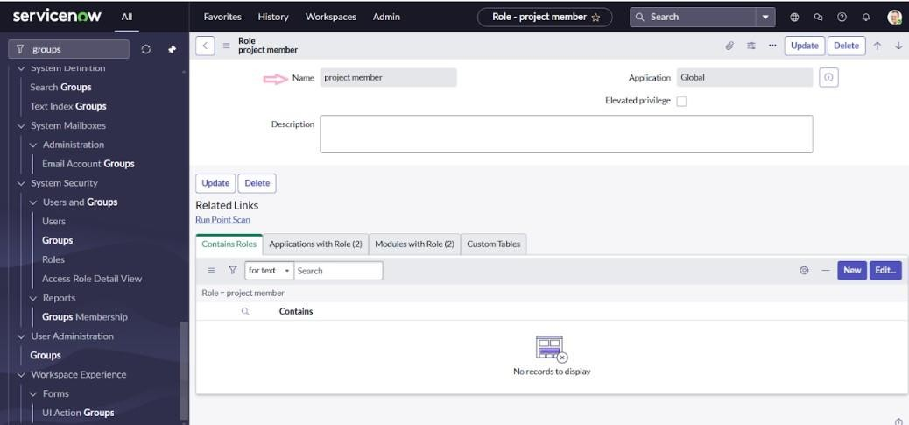
- Create another role by clicking on the New button and filling in the required details such as Name and Description.
- Click on the Submit button to save and create the additional role.

Assigning users to groups

Assign roles to 1st user:
- Click on All in the navigation pane and search for Users.
- Select Users under the System Definition module.
- Open the (Project Manager) user record.
- Under the Roles related list, click on the Edit button.
- Select the project_member role and click Save.
- Again, click Edit and add the u_project_table and u_task_table roles.
- Click Save, then click Update to finalize and save the changes.
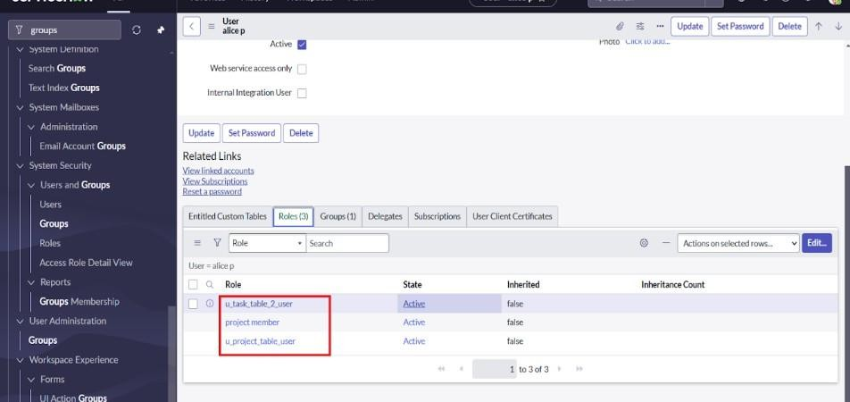

Assign roles to bob user :
- Click on All in the left navigation pane and search for Users.
- From the results, select Tables under the System Definition module.
- Locate and open the Bob P (Team Member) user record from the user list.
- Scroll down to the Roles section and click on the Edit button to manage user roles.
- From the available roles, select the team_member role and assign the necessary table roles to Bob.
- Click on Save and then Update to apply and confirm the changes to Bob’s profile.
- Go to the top-right corner, click on the Profile icon, and choose Impersonate User → Bob to switch to his account.
- Once impersonated as Bob, navigate through the application to verify that the Task Table is visible and accessible for him.

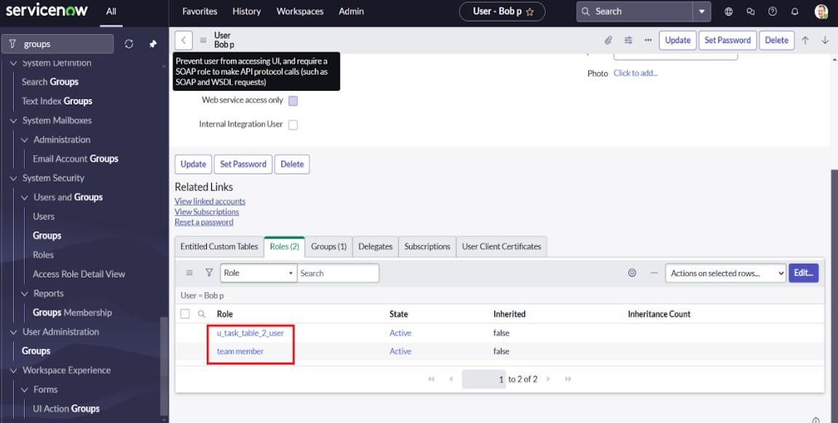

Application access

Assign table access to application :
- When you create a new table, ServiceNow automatically generates an application and a module for that table.
- In the Application Navigator, search for the Project Table application.
- Click on Edit Module to modify its access settings.
- Assign the Project Member role to the Project Table application.
- Next, search for the Task Table2 application and click on Edit Application.
- Assign both the Project Member and Team Member roles to the Task Table2
application.

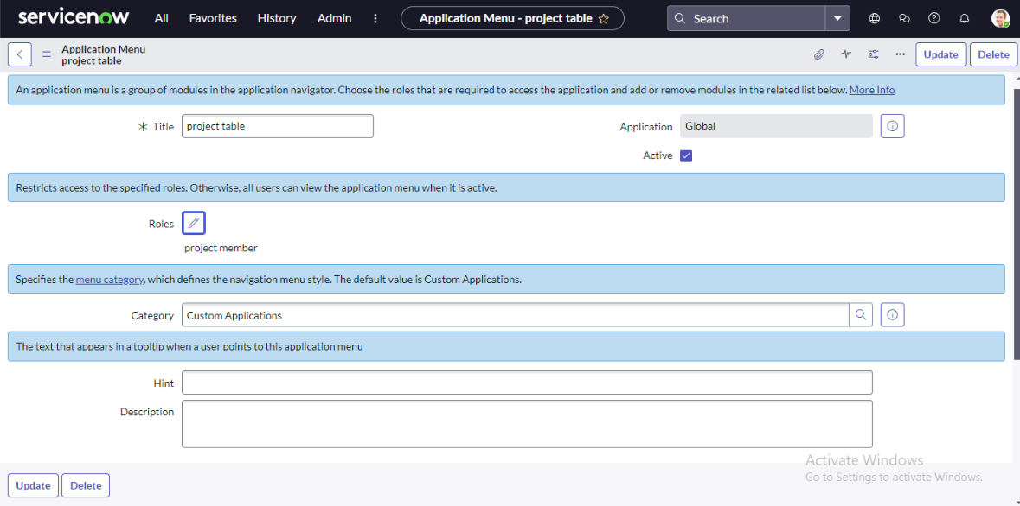

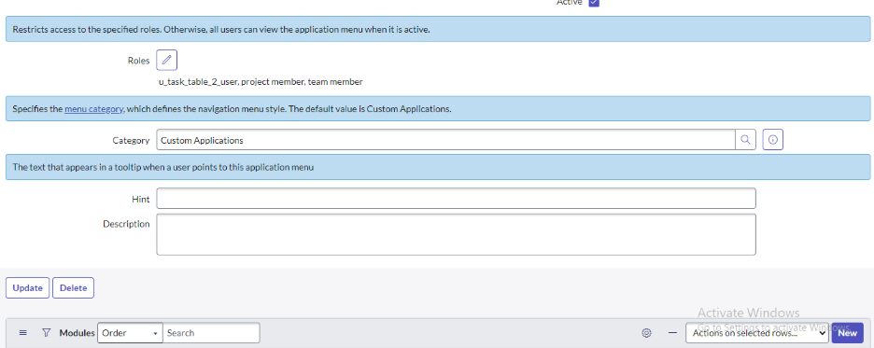

Access control list

Creating ACL :
- Click on All in the left-side navigation pane and type ACL in the search bar to locate access control settings within the platform.
- From the search results, select Access Control (ACL) under the System Security module to open the list of existing access control rules.
- Before creating a new ACL, click on Elevate Role at the top-right corner to temporarily gain the security_admin role required for modifying or creating ACLs.

- Once elevated, click on the New button to open the ACL creation form and start defining a new access control rule.
- In the form, carefully fill in the required details such as the Type (record or field), Operation (read, write, delete, etc.), and the Table or Field name for which the ACL will be applied, then add appropriate conditions and roles before saving.
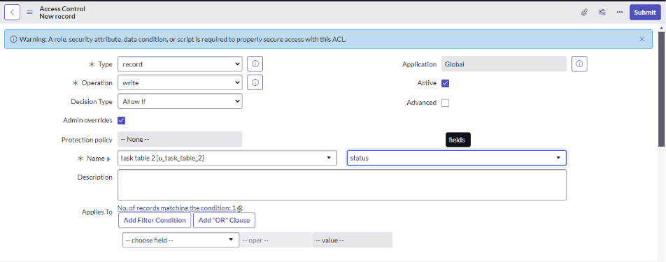

- Scroll down to the Requires Role section in the ACL form.
- Double-click to insert a new row and add the necessary role permissions.
- Enter the Task Table and assign the Team Member role to it.
- Click on the Submit button to save the ACL configuration.
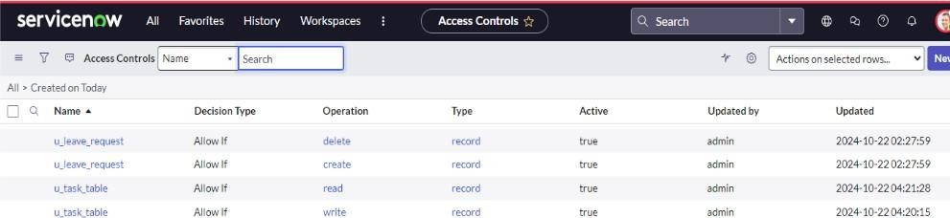
- Similarly, create four more ACLs for the following fields by repeating the same process — defining the table, selecting the appropriate operation, and assigning the required roles before saving each ACL.

- Click on the Profile icon located at the top-right corner of the ServiceNow interface.
- Select the Impersonate User option from the dropdown menu.
- Choose the Bob user from the list to log in as that user.
- Go to All in the application navigator and select Task Table2 from the application menu bar.
- Verify that the Comment and Status fields are editable, confirming that Bob has edit access
to those fields.

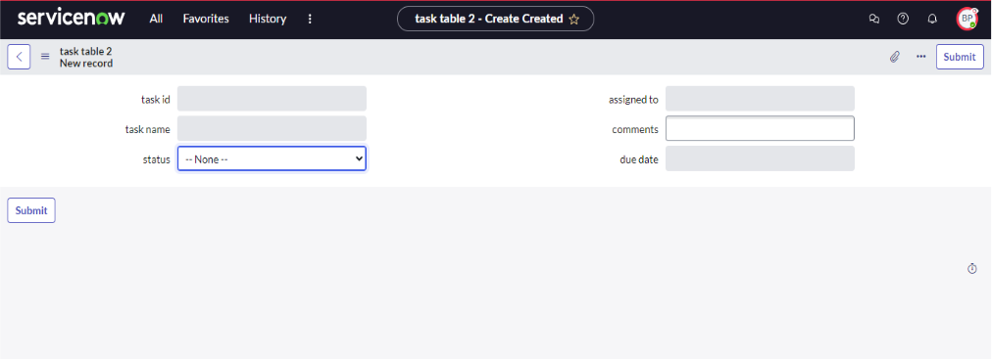

Flow

- Creating a Flow to Assign operations ticket to group :
- Click on All in the left navigation pane and search for Flow Designer.
- Select Flow Designer under the Process Automation module to open the flow configuration workspace.
- Once Flow Designer opens, click on the New button and select Flow from the available options.
- In the Flow Properties section, enter the Flow Name as “Task Table”.
- Ensure that the Application is set to Global before proceeding.
- Finally, click on Build Flow to start designing the workflow for the Task Table.

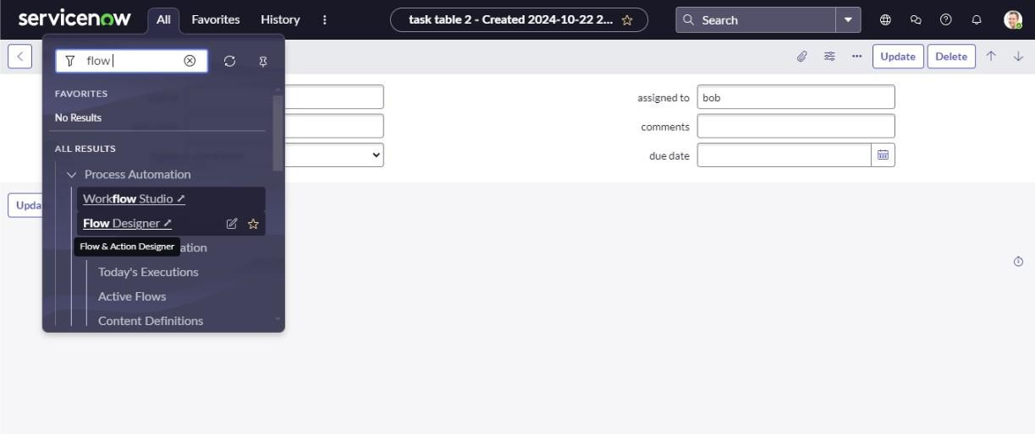

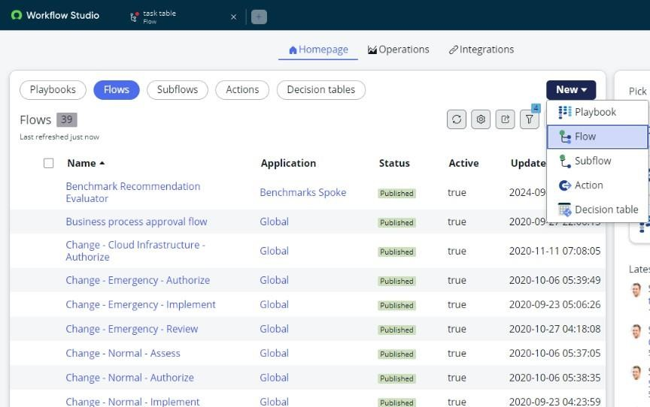

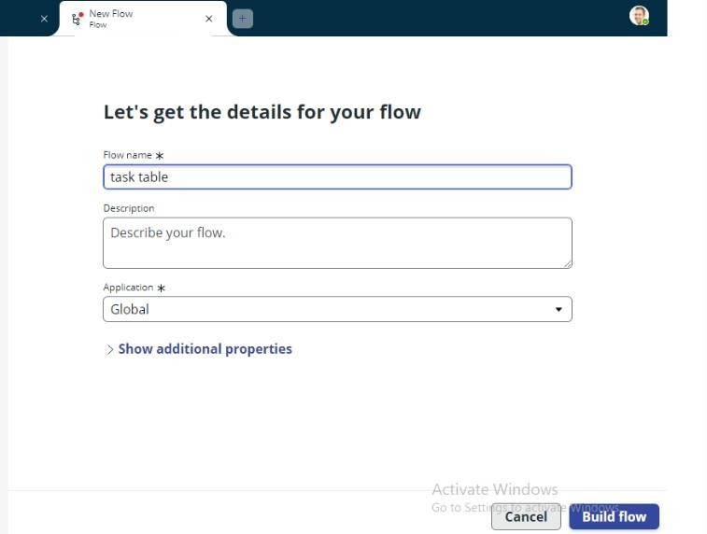

Creating Trigger:
- Click on Add a Trigger to define when the flow should start.

In the trigger selection window, search for “Create Record” and select it as the trigger type.
- In the configuration section, set the Table Name to “Task Table” to specify where the trigger will apply.
- Define the following conditions for the trigger:
  - Field: Status Operator: is Value: In Progress
  - Field: Comments Operator: is Value: Feedback
  - Field: Assigned To Operator: is Value: Bob

After entering all the conditions, click on Done to save and confirm the trigger configuration.

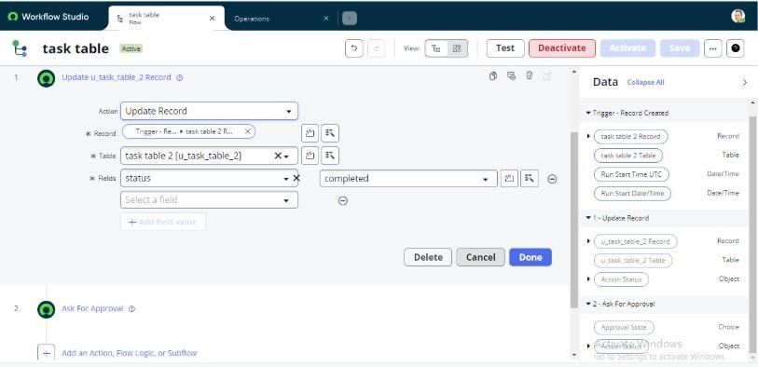

ACTIONS:

Under the Actions section of the Flow Designer, click on Add an Action to define what happens after the trigger event.
- In the action selection window, search for “Ask for Approval” and select it from the list.
- In the Record field, drag and drop the appropriate fields from the Data Panel

on the right side to link the record details.
- The Table field will be automatically populated based on the selected record.

- Set the Approve Field to “Status” to capture the approval outcome in that field.
- Assign Alice P as the Approver who will receive and handle the approval request.

Once all details are configured, click on Done to save the action settings.

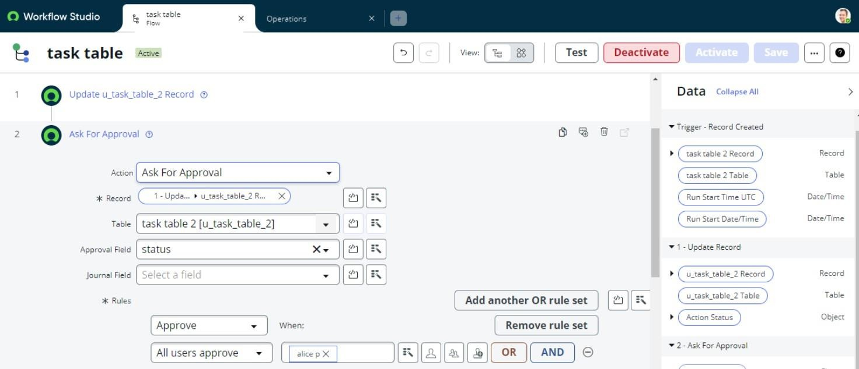

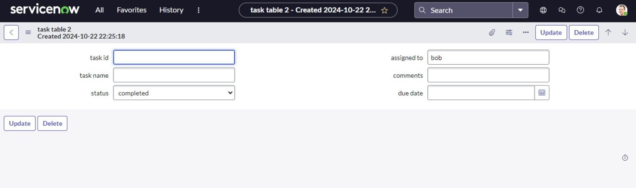

- Go to the Application Navigator in ServiceNow and search for My Approvals.
- Click on My Approvals under the Service Desk module to view the pending approval requests.
- You will see that Alice p has received an approval request generated by the flow.
- Right-click on the Requested approval record and select Approve to complete the approval process.

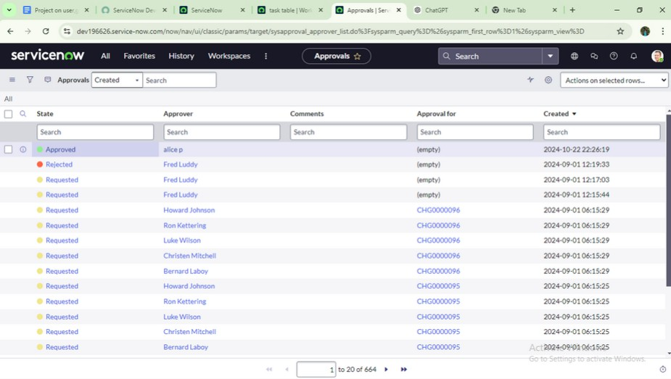

Result :
- The project began with the creation of users, groups, and roles to establish a structured access control system. Each user was assigned specific roles — Alice as the Project Manager and Bob as the Team Member — ensuring clear responsibilities. Next, tables such as Project Table and Task Table2 were created, and appropriate roles and permissions were assigned to control access.

- Access Control Lists (ACLs) were then configured to provide secure data visibility and editing rights. After that, a Flow Designer automation was built, where a trigger was set to activate whenever a new task record was created under certain conditions.

- When a task met these conditions, the flow automatically generated an approval request for Alice. Upon Dharshni’s approval, Bob could access and update the task details, confirming the workflow’s successful execution.

- Through this process, the project achieved a seamless workflow where automation, security, and collaboration worked together — improving efficiency, ensuring proper access control, and enabling smooth project management from start to finish.



Conclusion :
This scenario demonstrates a well-organized project management process, emphasizing the responsibilities of Alice and Bob within a clearly defined workflow. With Alice managing approvals and Bob handling task execution, the team works together efficiently to achieve project goals. The use of tables helps structure important data, making it easier to monitor projects, tasks, and progress. Overall, this system improves accountability, streamlines communication, and supports the successful delivery of projects.

